University Medical Center Goes Green

Volume 1, Number 1 January 2016

University Medical Center continues its commitment to implementing environmentally friendly practices and fostering ecologically sustainable communities. This newsletter focuses on practices being implemented at the Center in accordance with government guidelines.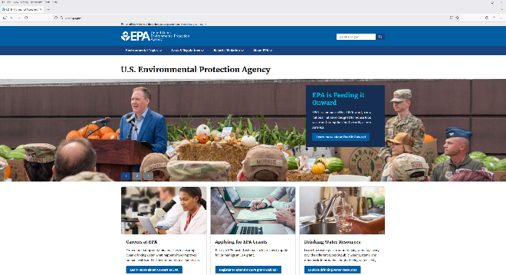

**Recycling Trash**

More than 300 recycling bins have been placed beside trash bins throughout the hospital. That means that for every two to four trash or hazardous waste receptacles, there is now a bin to collect and process recyclable materials. Plastic and aluminum cups, bottles, and cans are the main articles that will be recycled in these bins, which are clearly marked with the recycling sign to differentiate them from other types of waste. In addition to these bins, two extra cardboard billiards have been installed to help with our increase in cardboard box recycling.

**Harvesting Daylight**

Low-watt energy-efficient light bulbs have replaced traditional lights throughout the center and energy-efficient lamps, and daylight controls have been installed. This move will conserve energy and cut down on the hospital’s use of electricity.

**Greener Landscaping**

New landscaping incorporates the use of regionally native plants and a reduction in turf, thus reducing the need for extensive use of power equipment. Water-saving devices and a system that uses 100% recycled water have been installed outside the center, replacing the previous watering system. Plants and fauna stay green in an environmentally conscious manner.

**Greener Grocer**

The hospital cafeteria has eliminated non-compostable materials and is using recyclable paper goods. In addition, a vegetable and herb garden outside the southeast corner of the Palomar Pavilion supplements fruits and vegetables purchased at local farmers markets.

**Greener Records**

Electronic medical records and consent forms have replaced a paper system, conserved not only paper, but also reclaimed valuable working and storage space.

**“Everything we can do here at University Medical Center to protect our environment and conserve resources sets the example for others to do the same.” Emily Lynn—Facilities DirectorA green recycle symbol
**